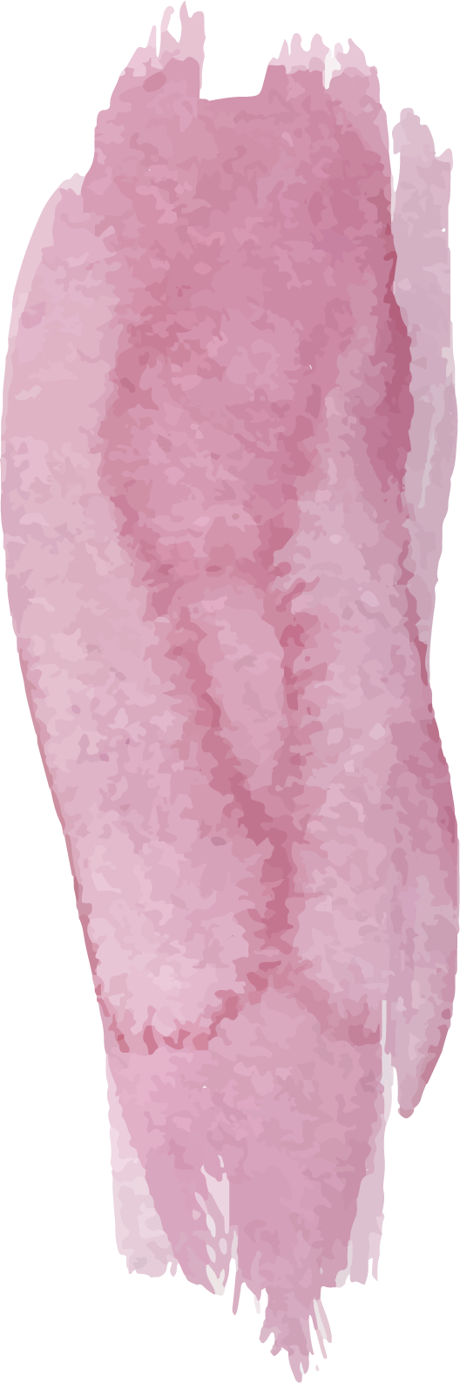
Year 5 Curriculum Overview

 | Autumn |  |  | Spring |  |  |  |  |  | Summer
 | 1 |  | 2 | 1 |  |  | 2 |  |  | 1 |  | 2
Science | Properties And Changes Of Material  How does a material’s property suit its role?  What does soluble mean?  How can mixtures be separated?  How can solutions be separated?  Which changes cannot be reversed and why? | Force  What do we already know about contact forces?  What is the effect of friction?  What is the effect of air resistance?  What do already know about non-contact forces?  What is upthrust?  What is a machine? |  |  | Earth And Space  What is the solar system like?  Why does the sun appear to move across the sky?  Why do we have day and night?  What are the phases of the moon?  Can we explore the solar system through a research activity? |  |  |  | Living Things And Their Habitats  What is the difference between a mammal and an amphibian?  What is the difference between an insect and a bird?  What is similar/different between the lifecycles of a mammal, an insect, an amphibian and a bird?  How do living things reproduce?  Can we investigate reproduction in plants? |  | Animals, Including Humans  What is the human timeline?  What happens to our bodies as we get older?  How do we change into adults?  How does human and animal lifespan compare?
History | Invaders And Settlers  How did the daily life of the Anglo-Saxons and Vikings impact Britain?  Why did the Anglo-Saxons and Vikings invade Britain?  How were villages ruled and managed? |  |  |  | Tudors  What was it like to be a Tudor?  What was life like during the plague?  Can you tell me about Henry VIII, Francis Drake, Shakespeare and Elizabeth I?  Who were Henry VIII’s wives?  Why was the church of England established? |  |  |  | Rivers  Can you name significant members of the Pease Family?  What did the Pease Family do for Darlington?
Geography | Invaders And Settlers  Where did the Vikings come from?  Where did the Vikings settle in the UK?  Can you name places that are Viking/Anglo-Saxon in origin?  Can you give examples of place names that are local to Darlington and Viking in origin?  What were Anglo-Saxon and Viking villages like? |  |  |  | Tudors  How do Tudor maps of the world differ to today?  Can you name a Tudor explorer and where they journeyed to? |  |  |  | Rivers  Can you describe the journey of the River Tees from Cow Green Reservoir to the North Sea?  How was High Force formed?  What are the key features of the River Tees?  Why was the River Tees so important to the area?
Art | Sculpture: Modroc  Artist: Andy Goldsworthy  Artist Showcase  Learning A New Skill  Practising The New Skill  Appling The New Skill  Creating The Artwork  Evaluation And Assessment |  |  |  | Portraits  Artist: Hans Holbein  Artist Showcase  Learning A New Skill  Practising The New Skill  Appling The New Skill  Creating The Artwork  Evaluation And Assessment |  |  |  | Abstract Expressionism  Artist: Jackson Pollock  Artist Showcase  Learning A New Skill  Practising The New Skill  Appling The New Skill  Creating The Artwork  Evaluation And Assessment
Design Technology | MECHANISMS: Viking/Anglo-Saxon Scene (CAMS)  Analysing  Practising  Designing  Making  Evaluating  Modifying And Improving |  |  |  | MECHANISMS: Motorised Tudor Carriage (Pulleys Or Gears)  Analysing  Practising  Designing  Making  Evaluating  Modifying And Improving |  |  |  | STRUCTURES: Bridges (Frame Structures)  Analysing  Practising  Designing  Making  Evaluating  Modifying And Improving
PE | Swimming
PE | Athletics  Dodgeball | Dance  Basketball |  |  | Gymnastics  Football | Netball  Communication And Tactics |  |  | Cricket  Health Related Exercise |  | Athletics  Rounders
Music | Durham Music Services
RE | What is the best way for a Muslim to show commitment to God?  How do people show that they are committed to something?  Why might prayer be important to Muslims?  Why might helping the needy support a Muslim in showing commitment to God?  How might fasting support a Muslim in showing commitment to God?  How might Muslims show commitment to God?  How could I improve upon my commitments? | Is the Christmas story true?  How can versions of events be different?  What are some versions of the Christmas story?  How are versions of the Christmas story from the Bible similar?  What might a Christian believe is true from the Christmas story?  How can ‘true’ mean different things to different people?  How can people see truths in stories which may not be completely true? |  |  | How is the Qur’an vital to Muslims today?  How might written guidance impact my behaviour?  Which events were important in the Night of Power?  How might Muslims show respect to the Qur’an?  How might sayings from the Qur’an be interpreted?  How might a Muslim’s interpretation of the Qur’an affect how they choose to live today?  How would I like something important to me to be treated? |  |  | How significant is it for Christians to believe that God intended Jesus to die?  What is the difference between destiny and free will?  Was the crucifixion a consequence of the events of Holy Week?  Did Jesus know that the crucifixion was part of God’s plan? (Last Supper to praying in the garden)  Did Jesus know that the crucifixion was part of God’s plan?  Does the evidence show that God intended Jesus to be crucified and rise again or was the crucifixion the consequence of the events of Holy Week?  What do I think about people with a strong sense of purpose? | What is the best way for a Hindu to show commitment to God?  How can commitment be demonstrated in different ways?  What is the significance of Puja?  How can Hindus worship and show devotion to the gods and goddesses?  Why might a Hindu pilgrimage to the Ganges show commitment to God?  How might a Hindu show commitment to God?  How do I show commitment? |  | What is the best way for a Christian to show commitment to God?  What is a dilemma and how might it test someone’s commitment?  How do the 10 Commandments help Christians to show their commitment to God?  How does ‘Love your neighbour as yourself’ help Christians to show their commitment to God?  How do prayer and worship practices help Christians to show their commitment to God?  How do different practices have different levels of significance to Christians?  How might belief help someone stay committed during hard times?
Computing | Systems And Searching  Systems  Computer System And Us  Searching The Web  Selecting Search Results  How Search Results Are Ranked  How Are Searches Influenced | Video Production  What is video?  Filming Techniques  Using A Storyboard  Planning A Video  Importing And Editing Video  Video Evaluation |  |  | Selection In Physical Computing  Connecting Crumbles  Combining Output Components  Controlling With Conditions  Stating With Selection  Drawing Designs  Writing And Testing Algorithms |  |  | Flat-File Databases  Creating A Paper-Based Database  Computer Databases  Using A Database  Using Search Tools  Comparing Data Visually  Databases In Real Life | Vector Drawing  The Drawing Tools  Creating Images  Making Effective Drawings  Layers And Objects  Manipulating Objects  Becoming A Graphic Designer |  | Selection In Quizzes  Exploring Conditions  Selecting Outcomes  Asking Questions  Planning A Quiz  Testing A Quiz  Evaluating A Quiz
PSHE | My Healthy Self: How can I support my mind and body as I grow?  What do food labels really tell us?  How active am I and how can I move more?  What are the different types of physical activity and how do they affect us?  How can I recognise complex feelings?  How can I respond to strong and complex feelings?  How can we tell when someone might need support with their mental health? | Connecting With Others: Why are healthy relationships important?  What makes me who I am?  How do families show commitment to each other?  How can families support and protect each other?  What helps us make and maintain healthy friendships?  How can we manage challenges in friendships?  How can I be assertive and respectful? |  |  | The Online World: How am I influenced by what I see online?  How do adverts try to influence us online?  How are adverts chosen for me online?  How else am I influenced online?  How do online trends shape our choices offline?  How does what we see online influence our viewpoints?  How can some online messages be misleading? |  |  | Citizenship: How can we make a difference in our communities and beyond?  How can we show care for others?  How do people contribute to the community?  How does the UK government work?  What is the role of a local councillor?  What are pressure groups?  How can people influence the decisions made by the government? | Growing Up: How can I manage the changes to my body and emotions as I grow up?  How will my body grow during puberty?  How can I keep myself clean and hygienic?  How can we treat others with kindness during puberty?  How can I manage my emotions and feelings during puberty?  What is a period?  How can I challenge behaviour which crosses personal boundaries? |  | Citizenship: How can we be in control of our money?

