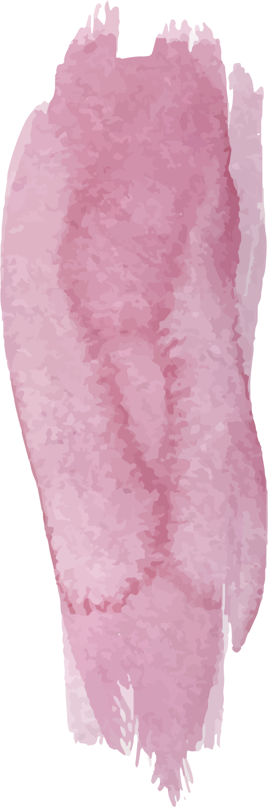
Year 2 Curriculum Overview

 | Autumn |  |  | Spring |  |  |  |  |  | Summer
 | 1 |  | 2 | 1 |  |  |  | 2 |  | 1 |  | 2
Science | Everyday Materials  What are things made from?  Do different materials have different properties?  What materials are these objects made from and why?  Can we change the shape of solid objects by squashing, bending, twisting and stretching?  Why can some solid objects be manipulated more than others?  What are solids, liquids and gases? |  |  |  | Living Things And Their Habitats  What is alive and what is not?  What do all living things have in common?  What is a habitat?  What plants and animals live in our school environment?  What are food chains?  Why do plants and animals need each other? |  |  |  | Plants  What is a plant?  How do plants grow?  What do plants need to grow and stay healthy?  Can we use our knowledge to grow a healthy plant?  What happens when plants do not get all of the things they need? |  | Animals, Including Humans  What is an animal?  What happens to our bodies as we grow?  Do other animals grow in the same way as us?  What do all animals need to stay alive?  Why do we eat different types of food?  Why do humans need to exercise?  What is hygiene and why is it important?
History | Transport  What was it like to be an explorer?  Who was Captain Cook?  Where did he sail to?  Can you describe life on a ship?  Who was George Stephenson? |  |  |  | Dirty Beasts  What were hospitals like in the past?  Why was Florence Nightingale called ‘The Lady with the Lamp’?  Why did hospitals need to change?  Why was Mary Seacole important? |  |  |  | The Seaside  Why was Saltburn a popular Victorian holiday destination?  What did Victorians do at Saltburn?  How are holidays different now?
Geography | Transport  Can you name the seven continents?  Can you name some seas, oceans and locate where they are?  Can you name countries in the Northern Hemisphere?  Can you name countries in the Southern Hemisphere?  What is the equator?  Can you label north, east, south and west? |  |  |  | Dirty Bests  What are the key geographical features of Darlington?  What types of businesses are in Darlington?  Draw a type of house you will see in Darlington.  Can you describe the route to Darlington Hospital? |  |  |  | The Seaside  Can you name some of the geographical features of Saltburn?  What are the similarities between Saltburn and Darlington?  What are the differences between Saltburn and Darlington?
Art | Sculpture: Clay  Artist: Anthony Gormley  Artist Showcase  Learning A New Skill  Practising The New Skill  Appling The New Skill  Creating The Artwork  Evaluation And Assessment |  |  |  | Printing  Artist: Angie Lewin  Artist Showcase  Learning A New Skill  Practising The New Skill  Appling The New Skill  Creating The Artwork  Evaluation And Assessment |  |  |  | Cubist Movement  Artist: Pablo Picasso  Artist Showcase  Learning A New Skill  Practising The New Skill  Appling The New Skill  Creating The Artwork  Evaluation And Assessment
Design Technology | MECHANISMS: Vehicle  Analysing  Practising  Designing  Making  Evaluating  Modifying And Improving |  |  |  | TEXTILES: Hospital Apron  Analysing  Practising  Designing  Making  Evaluating  Modifying And Improving |  |  |  | STRUCTURES: Pier  Analysing  Practising  Designing  Making  Evaluating  Modifying And Improving
PE | Jumping  Dodgeball | Dance  Hands |  |  | Gymnastics  Feet |  | Hands  Team Building |  | Rackets, Bats And Balls  Health And Wellbeing |  | Jumping And Running  Games For Understanding
Music | Pulse, Rhythm And Pitch  Music Is My Soul  Hey Friends  Hello | Playing In An Orchestra  Sparkle In The Sun  Listen To The World Around You  The Orchestra Song |  |  | Inventing A Musical Story  Rainbows  Hands, Feet, Heart  All Around The World |  | Recognising Different Sounds  Helping Each Other  The Music Man  Let’s Sing Together |  | Exploring Improvisation  I Wanna Be In A Band  Music Is All Around  Saying Sorry |  | Our Big Concert  The Sunshine Song  Four White Horses  Down By The Bay
RE | What might Hindus learn from the story of Rama and Sita and the celebrations of Diwali?  What does it mean to belong?  What happens in the story of Rama and Sita?  How does the story of Rama and Sita help Hindus understand right and wrong?  How might Hindus celebrate Diwali?  How does the story of Rama and Sita inform some elements of Hindu practice?  What feelings can a sense of belonging bring? | Why do Christians believe God gave Jesus to the world?  Why might the world need special care?  Why might Christians believe that Jesus is their saviour?  What might a Christian use to prepare for Christmas?  What gifts might Christians think Jesus brought into the world?  Why might Christians believe that Jesus was a gift from God?  How can I help people in the world by showing love? |  |  | Is it possible to be kind to everyone all of the time?  How can we be kind to someone, even if it is difficult?  What do Christians believe Jesus said about kindness?  Why do Christians believe Jesus treated someone unpopular with kindness?  Why do Christians believe Jesus treated someone who had let him down with kindness?  Why do Christians believe they should be kind?  Why is it important to be kind? | How important is it to Christians that Jesus came back to life after his crucifixion?  How can memories help us to remember someone special?  What happened in the Easter story?  (Up to the crucifixion)  What happened in the Easter story?  (After the crucifixion)  What happened in the Easter story?  (After the resurrection)  What might Christians believe happened on and after Easter Sunday?  Which symbols might help us to celebrate Easter? |  |  | Why do Hindus use symbols?  What might different symbols mean to me?  What is the Aum symbol and how is it used?  What is the Hindu story of creation and how does the Aum feature?  Why might a lotus flower be an important symbol for Hindus?  What are some Hindu symbols and how might they impact Hindus?  Why might a symbol be meaningful to me? |  | How important is the Qur’an to Muslims?  How can stories help us learn?  How might a Muslim show respect to the Qur’an?  What happened on the Night of Power?  Which instructions from the Qur’an might Muslims follow? (1)  Which instructions from the Qur’an might Muslims follow? (2)  Which values are important to me?
Computing | IT Around Us  What is IT?  IT In School  IT In The World  The Benefits Of IT  Using IT Safely  Using IT In Different Ways | Digital Photography  Taking Photographs  Landscape Or Portrait  What makes a good photograph?  Lighting  Effect  Is it real? |  |  | Robot Algorithms  Giving Instructions  Same But Different  Making Predictions  Mats And Routes  Algorithm Design  Debugging |  | Pictograms  Counting And Comparing  Enter The Data  Creating Pictograms  What is an attribute?  Comparing People  Presenting Information |  | Digital Music  How Music Makes Us Feel  Rhythms And Patterns  How Music Can Be Used  Notes And Tempo  Creating Digital Music  Reviewing And Editing Music |  | Programming Quizzes  ScratchJr Recap  Outcomes  Using A Design  Changing A Design  Designing And Creating A Program  Evaluating
PSHE | My Healthy Self: How can we look after our bodies?  How does moving my body make me feel?  Why is sleep important?  What foods can help me stay healthy?  How can I make some healthy food and drink choices?  What can I do to keep my teeth clean and healthy?  How can I make healthy choices every day? | Connecting with others: How can I build safe, kind and caring relationships with others?  How are we all different and the same?  How are families different and the same?  How can I show my feelings kindly and calmly?  How can I let others know what is okay or not okay for me?  Who can I talk to if something does not feel right?  What should I do if someone is being unkind again and again? |  |  | The Online World: How can we stay safe online?  What can we do online and how can we do it safely?  Who can see information shared online?  What is private information?  How do I know if private information has been shared online?  Is everything we see online real?  What should I do if something online worries me? |  | Citizenship: How do people belong to a community and earn money?  Where do we belong?  How can different people contribute to my community?  What jobs do people do in our local community?  What other jobs might people do?  What is money?  Where does money come from? |  | Growing up: How can we look after and respect our bodies as we grow?  How do we grow and change?  How will I change as I grow up?  Do I make the rules about my own body?  How can I talk about my body?  How can we show respect for each other’s bodies?  Who can I talk to if I do not feel safe? |  | Staying safe: How can I make safe choices in different places?  What makes my body special?  How can I keep my body safe?  How can I make safe choices at home?  How can I stay safe in different places?  What can I do if I cannot find my trusted adult?  How can I stay safe around water?

