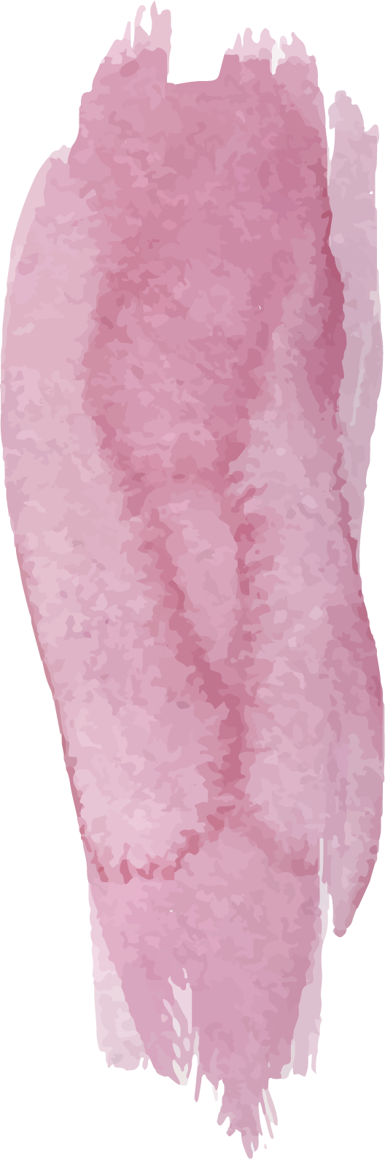
Year 1 Curriculum Overview

 | Autumn |  |  | Spring |  |  |  |  |  | Summer
 | 1 |  | 2 | 1 |  |  |  | 2 |  | 1 |  | 2
Science | Seasonal Change  What do we know about weather?  How does the weather change across the seasons?  How does day length vary between the seasons?  How do humans, plants and animals adapt to seasonal changes?  Can we set up a weather station to monitor and record different weather over time?
Science | Everyday Materials  What is a material?  How can we sort everyday objects according to the material they are made from?  What are the properties of common materials?  How do we sort materials based on their properties?  Which materials would be best and why? |  |  |  | Animals, Including Humans  What are the main parts of the body?  What are our senses?  Are there different kinds of animal?  What makes a bird a bird? A fish a fish? A reptile a reptile?  Do animals have the same senses as humans?  Do animals feed in different ways? |  |  |  | Plants  What is a plant?  What are wild plants and where can they live?  What are garden plants and where can they live?  Is a tree a plant?  What types of trees are there?
History | Around Us  Can you put these three events into a sequence: go to school, wake up, eat breakfast?  What were schools like in the past?  How have schools changed?  What were homes like in the past?  How have homes changed throughout time? |  |  |  | People Who Help Us  Where did the Great Fire take place?  How did the Great Fire start?  When did the Great Fire happen?  Why did the fire spread and keep burning?  Who wrote a diary about the fire of London and what did it say?  What important lessons have we learnt about the fire of London? |  |  |  | The Park  How does our local park look different to a Victorian park?  What can you do in our local park that Victorians couldn’t do?  Who was Edward Pease?
Geography | Around Us  Can you name a human feature?  Can you name a physical feature?  What is a human feature?  What is a physical feature?  What is an aerial view map? |  |  |  | People Who Help Us  Can you explain the weather pattern for the four seasons?  Name a physical feature in the local area.  Where in the local area could you find a human feature? What is it? |  |  |  | The Park  Can you name the four countries in the UK?  What are the capital cities in the UK?  Can you locate Darlington on a map of the UK?  Can you name the surrounding seas in the UK?
Art | Sculpture: Collage  Artist: George Braque  Artist Showcase  Learning A New Skill  Practising The New Skill  Appling The New Skill  Creating The Artwork  Evaluation And Assessment |  |  |  | Abstract Art  Artist: Wassily Kandinsky  Artist Showcase  Learning A New Skill  Practising The New Skill  Appling The New Skill  Creating The Artwork  Evaluation And Assessment |  |  |  | Pop Art  Artist: Andy Warhol  Artist Showcase  Learning A New Skill  Practising The New Skill  Appling The New Skill  Creating The Artwork  Evaluation And Assessment
Design Technology | STRUCTURES: Making A Chair  Analysing  Practising  Designing  Making  Evaluating  Modifying And Improving |  |  |  | FOOD TECHNOLOGY: Making A Sandwich  Analysing  Practising  Designing  Making  Evaluating  Modifying And Improving |  |  |  | MECHANISMS: Moving Pictures  Analysing  Practising  Designing  Making  Evaluating  Modifying And Improving
PE | Running  Jumping | Dance  Hands |  |  | Gymnastics  Feet |  | Hands  Team Building |  | Rackets, Bats, Balls And Balloons  Health And Wellbeing |  | Jumping And Running  Games For Understanding
Music | My Musical Heartbeat  Find The Beat  1-2-3-4-5  Head, Shoulders, Knees And Toes  Shapes  We Talk To Animals | Dance, Sing And Play!  Twinkle, Twinkle Little Star  In The Orchestra  Daisy Bell  Dancing Dinosaurs  Rock-a-bye Baby |  |  | Exploring Sounds  If You’re Happy And You Know It  Sing Me A Song  Sparkle  Rhythm In The Way We Walk  Big Bear Funk |  | Learning To Listen  Days Of The Week  Name Song  Cuckoo  Upside Down  Hush Little Baby |  | Having Fun With Improvisation  Getting Dressed  Dress Up  Brush Our Teeth  Get Ready  Up And Down |  | Let’s Perform Together!  The Bear Went Over The Mountain  In The Sea  Alice The Camel  Ten Green Bottles  Zootime
RE | What do Christians believe about God?  How can we respect the work of a creator?  What is the Christian creation story?  How do Christians think God wants them to behave towards the world?  How do Christians think God wants them to behave towards others?  What are some Christian beliefs about God?  How can we take care of the world or somebody? | What gifts might Christians in my town have given Jesus if he had been born here rather than in Bethlehem?  How can we choose meaningful presents?  Why might the Christmas story be special to Christians?  Why might the gifts Jesus received have been meaningful in Bethlehem?  How might gifts given today be different to those from the Christmas story?  What gifts might Christians give to Jesus?  How might it feel to give and receive meaningful gifts? |  |  | Who is God to Hindus?  How might we show different parts of our personality to different people?  Who is the supreme deity in Hinduism?  What is the Trimurti and what does each deity represent?  What do Hindus believe about God?  How might Hindu beliefs about God impact how they treat living things?  How can we show respect to living things? | Why was Jesus welcomed like a king or celebrity by the crowds on Palm Sunday?  Which qualities do I admire in people?  Why might Jesus have been special or important to the people around him?  What happened in the Easter story?  (Before And During Palm Sunday)  What happened in the Easter story?  (Palm Sunday To Easter Sunday)  Which symbols are in the Easter story? Who do I admire and why? |  |  | Who is God to Muslims?  How can we show respect?  Who is Allah to Muslims?  What do the 99 names of Allah mean?  How might a Muslim show respect to Allah in their lives?  What do the attributes of Allah mean?  How can I show people who are special to me that I care? |  | How important is the Prophet Muhammad to Muslims?  What might make somebody important?  Why was Muhammad chosen to be a prophet?  How were events in the life of Muhammad important to Islam?  Which of Muhammad’s sayings might help Muslims today?  Which events in Muhammad’s life are most important to Muslims today?  How can a special person be a good role model?
Computing | Technology Around Us  Technology In Our Classroom  Using Computer Technology  Developing Mouse Skills  Using A Computer Keyboard  Developing Keyboard Skills  Using A Computer Responsibly | Digital Painting  How can we paint using computers?  Ushing Shapes And Lines  Making Careful Choices  Why did I choose that?  Painting All By Myself  Comparing Computer Art And Painting |  |  | Moving a Robot  Buttons  Directions  Forwards And Backwards  Four Directions  Getting There  Routes |  | Grouping Data  Label And Match  Group And Count  Describe An Object  Making Different Groups  Comparing Groups  Answering Questions |  | Digital Writing  Exploring The Keyboard  Adding And Removing Text  Exploring The Toolbar  Making Changes To Text  Explaining My Choices  Pencil Or Keyboard |  | Introduction to Animation  Comparing Tools  Joining Blocks  Make A Change  Adding Sprites  Project Design  Following My Design
PSHE | My healthy Self: How can we look after our emotions?  What emotions can we recognise?  When and why do people show different emotions?  How can emotions change?  What helps us to feel calm or excited?  What might make us feel worried, annoyed or upset?  What can we do when our feelings get tricky? | Connecting With Others: How can I help myself and others feel safe and happy?  What makes me special?  How do families show love and care for each other?  What helps me feel safe and cared for?  What is a friend?  How can we have a kind and friendly class?  How should people behave towards others? |  |  | The Online World: How do we spend time online?  When am I online?  What can I do online and what can I do in person?  How should I behave when I use a device?  How can I balance screen time with in-person activities?  What should I do if I see something online that worries me?  How can I stay safe online? | Citizenship: How can I help others and the environment?  What do babies and toddlers need?  What do animals need?  How can we look after our school environment?  How can I share my ideas respectfully?  Who helps look after our local environment?  How do rules help everyone? |  |  | Health Protection: How can I protect myself and others in daily life?  How and why do we wash our hands?  How can I protect myself in any weather?  Who helps us stay healthy?  What should I do if I feel unwell?  How serious are different injuries?  How can we get help for serious illnesses or injuries? |  | Staying Safe: How can I stay safe?  How can I stay safe at home?  What is safe for our bodies?  What rules can keep me safe?  How can I stay safe near roads?  How might my body feel when something is unsafe?  Who can keep me safe?

