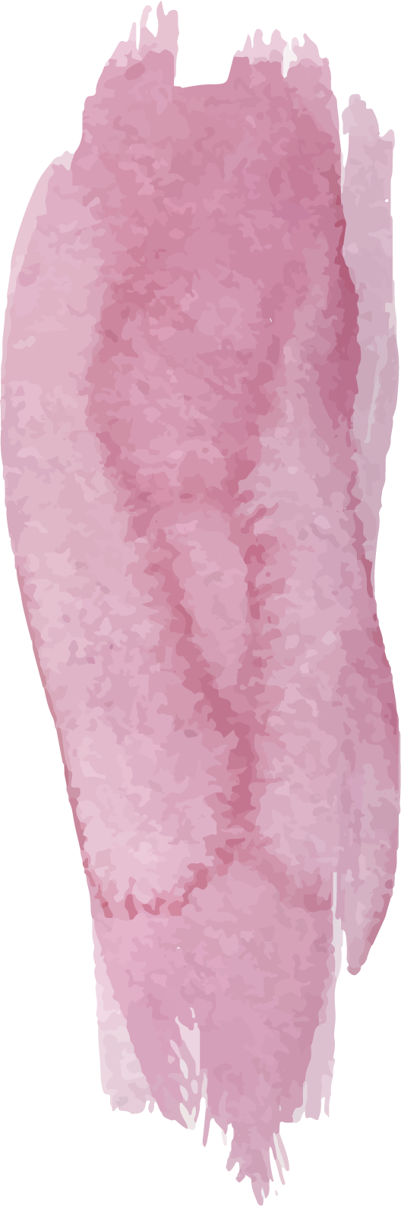
Nursery Curriculum Overview

 | Autumn |  |  | Spring |  |  |  |  | Summer
 | 1 |  | 2 | 1 |  |  | 2 |  | 1 |  |  | 2
Science | Seasonal Change  Understand the current season and typical weather, clothing and events.  To start to talk about own immediate environment.  To know we can help to look after our immediate environment e.g. tidy up, put rubbish in the bin.  Use all their senses in hands-on exploration of natural materials.  Talk about what they see, using a developing range of vocabulary.  Talk about the weather and appropriate clothing.
Science | Classifying  Match objects that pair together e.g. toothbrush and toothpaste.  Explore materials, e.g., mud, puddles, sand, grass and feathers.  Start to group living things e.g. plants, animals, people.  To sort different materials.  Remember where objects belong. | Forces  Use toys with buttons, flaps and simple mechanisms and begin to learn how to operate them.  To move an object by pushing, pulling etc.  To know that objects can move within the environment (wind, water etc).  Be able to pour water from a large bottle or jug into the tray. |  |  | States Of Matter  Talk about and notice the changes in materials, e.g., ice, snow, mud, chocolate and jelly.  Be able to pour water from a large bottle or jug into another container. | Animals, Including Humans  To know that trees, flowers and grass are plants and are living and grow.  To know that animals need things to live, just as humans do. |  | Plants  Living Things And Their Habitats  Plant seeds, care for them and know they will grow into a plant - relate this to life cycle of a plant.  Understand the life cycle of an animal - they are born, they grow – using stories.  Use images, stories and real experiences to develop an understanding of animal mothers and babies, e.g. Sheep / Lamb.  Begin to understand the need to respect and care for the natural environment and all living things. |  | States Of Matter  Forces  Explore collections of materials with similar and/or different properties.  Talk about different forces they can feel e.g. push.  Know that some materials change and give examples e.g. ice, baking  Be able to pour water from a smaller bottle or jug into another container.
History | You And Me  Be interested in photographs of themselves, their family and objects.  Talk about their immediate family.  To start to talk about own immediate environment.  To talk about similarities and differences within a group e.g. what did you have for breakfast, what do you watch on TV?  Show awareness of personal features when asked e.g. stand up if you are wearing a blue jumper, recognising when others have stood up, this is how they are similar. |  |  |  | Light And Dark  In pretend play, imitate everyday actions and events from own family and cultural background. | Down On The Farm  Enjoy playing with small world reconstructions, building on first-hand experiences, e.g., visiting farms, garages, train tracks, walking by river or lake. |  | Minibeasts  Talk about what they see, using a developing range of vocabulary. |  | Travel And Adventure  Continue developing positive attitudes about the differences between people.
Geography | You And Me  To start to talk about own immediate environment.  Remember where objects belong. |  |  |  | Light And Dark  Enjoy playing with small world reconstructions, building on first-hand experiences, e.g., visiting farms, garages, train tracks, walking by river or lake. | Down On The Farm  Enjoy playing with small world reconstructions, building on first-hand experiences, e.g., visiting farms, garages, train tracks, walking by river or lake. |  | Minibeasts  Talk about what they see, using a developing range of vocabulary. |  | Travel And Adventure  Know that there are countries beyond ours and that things are the same and different in these, in comparison to ours (use children’s experiences, photos and books).
Art | Mark Making  Surrealist  Artist: Frida Kahlo  Continue to explore colour and how colours can be changed e.g. combining colours.  Develop an understanding of marks to represent objects of marks to represent objects or images.  Use smaller paintbrushes, dabbers, and chunky mark making tools to make marks on paper. |  |  |  | Mark Making  Post-Impressionism  Artist: Vincent Van Gough  Starting to draw a recognisable picture.  Use a range of mark making tools to make deliberate marks on paper using the correct pressure. | Mark Making  Sculpture: Clay  Artist: Tanya Russel  Begin to develop finger strength and control in order to be able to manipulate and use tools independently and effectively. |  | Mark Making  Textured Artwork  Artist: Yumi Okita  Draws an identifiable picture of a person and basic animal.  Explores colour mixing with a range of media.  Show different emotions in their drawing/paintings.  Hold equipment/tools consistently in the same hand, e.g., pencil, paint brush, glue spreader.  Hold a pencil consistently in the same hand using a tripod grip for mark marking. |  |  | Mark Making  Transient Art  Artist: Walter Mason  Use drawing to represent ideas like movement or loud noises, such as movement/art to music.  Hold equipment/tools consistently in the same hand, e.g., pencil, paint brush, glue spreader.  Manipulate a range of tools and equipment in one hand.
Design Technology | STRUCTURES: Construction Set House  Use various construction materials, e.g., joining pieces, stacking vertically and horizontally, balancing, making enclosures and creating spaces.  Use tools for a purpose e.g. glue spreader.  To use spring loaded scissors. | FOOD TECHNOLOGY: Celebration Food  Cooking – combining different ingredients and then cooling or heating (cooking) them (taken from ‘Development Matters’). |  |  | STRUCTURES: Junk Model Houses  Begin to add purpose and meaning to their building with resources e.g. junk modelling, construction kits.  Use pincer grip to pick up small objects.  To use spring loaded scissors to make snips in paper. | FOOD TECHNOLOGY: Bread, Pancakes, Eggs  Cooking – combining different ingredients and then cooling or heating (cooking) them (taken from ‘Development Matters’). |  | MECHANISMS: Mobilo/Stickle Vehicle  Use a range of resources to build with a purpose or meaning e.g. junk modelling, construction kits, loose parts, wooden blocks.  Begin to develop complex stories using small world equipment like animal sets, dolls and dolls houses.  Use available resources to create props or creates imaginary ones to support play.  Play with one or more other children, extending and elaborating play ideas.  Have developed finger strength and control in order to be able to manipulate and use tools independently and effectively. |  |  | TEXTILES: Butterfly Wing Costume  Engage in imaginative play based on own ideas or first-hand or peer experiences.  Hold and operate scissors correctly to make snips in paper.  Hold equipment/tools consistently in the same hand, e.g., pencil, paint brush, glue spreader.  Manipulate a range of tools and equipment in one hand.
PE | Crawling And Walking | Hands |  |  | Gymnastics | Dance |  | Feet |  |  | Jumping
Music | Chant To The Animals | Creative Moves |  |  | Lilting Lullaby | Number Time |  | Well-Being Matters |  |  | Rhythm Adventure
RE* | Halloween  Bonfire Night | Diwali  Christmas |  |  | Chinese New Year | Easter |  | Respecting Others |  |  | Life Is Special
RE* | Be interested in photographs of themselves, their family and objects.  Talk about their immediate family.  To start to talk about own immediate environment.  To talk about similarities and differences within a group e.g. what did you have for breakfast, what do you watch on TV. |  |  |  | Remember and talk about significant events in their own life.  In pretend play, imitate everyday actions and events from own family and cultural background.  Enjoy playing with small world reconstructions, building on first-hand experiences, e.g., visiting farms, garages, train tracks, walking by river or lake. |  |  | Talk about what they see, using a developing range of vocabulary.  Begin to make sense of their own life story.  Ask questions about people outside their immediate family using different sources, e.g., current life.  Continue developing positive attitudes about the differences between people.  Show some awareness of the similarities and differences between themselves and others in more detailed ways e.g. hair colour, skin colour, height, glasses, siblings family members.
Computing | Everyday Technology  Remember where objects belong.  To start to talk about own immediate environment.  Use toys with buttons, flaps and simple mechanisms and begin how to operate them.  Explore unfamiliar objects by linking together different approaches: shaking, hitting, looking, feeling, tasting, pulling, turning and poking. | Taking Photographs  Be interested in photographs of themselves, their family and objects. |  |  | Operating Skills  Show an interest in technological toys with knobs, wind-up or pulleys, real objects, such as cameras, and touchscreen devices, such as mobile phones and tablets. | Collecting Data  To talk about similarities and differences within a group (from Autumn). |  | Investigating  Talk about what they see, using a developing range of vocabulary. |  |  | Programming  Talk about what they see, using a developing range of vocabulary.
PSHE | Kindness  Text: Sharing A Shell | Respect  Text: Oh No George! |  |  | Resilience  Text: The Jungle Run | Honesty  Text: Fabulous Pie |  | Independence  Text: It’s a George Thing!  . |  |  | Courage  Text: Small Florence

*Teaching of Eid depends on when it falls.

