Corporation Community Primary School
Pupil Premium Planned Grant Expenditure Report 2016/17
(September 2017 see below)
What is Pupil Premium Funding?
Pupil Premium Funding is allocated by the government to schools to support specific groups of children who are vulnerable to underachievement. Such pupils are identified as those entitled to free school meals (FSM), those looked after by the local authority and the children of armed service personnel.
The number of children identified as disadvantaged is way above the national average. 52% of pupils in the school fall under this classification compared to 18% nationally.

At Corporation Road Community Primary School we believe in supporting all children to do as well as they can, both socially and academically. In addition, we believe in supporting our families with issues that may impact on the children’s achievement and wellbeing.

Whilst we welcome Pupil Premium Funding we also recognise that prior to this specific funding we have always strived to support our children as best we can. Because of this, the ways in which we are using the funding are not necessarily new initiatives but rather a continuation of the good practice which was already in place.
We have identified five key areas on which we focus to improve outcomes for pupils eligible for pupil premium funding.
- Support for learning. To enable pupils to attain at least age related expectations and/ or make good progress in reading, writing and maths.
- Support for social development. To enable the child to be ready for learning by providing targeted support for behaviour, self-esteem and emotional well-being.
- Support for the curriculum. To ensure that pupils are able to access all aspects of the curriculum, including educational visits and residential trips, by providing financial support.
- Support for the family. To ensure that pupils are ready for learning by removing some of the barriers they experience through targeted work to improve attendance and punctuality, and through family support.
- Support for developing the environment across school to ensure children: have access to a library and books to promote a 'love of reading', are able to access an environment which inspires learning
- School became part of Lingfield Academy Trust in October 2016, as such this means that the school's budget now runs from September to September. In order to address this and update the school's Pupil Premium Report, a percentage of the budget has been added to this report to account for the number of Pupil Premium children on role from April 2017 - August 2017. This equates to an additional £72,000 added to the overall total.

Number of Pupils and pupil premium grant (PPG) received
Number on roll |  |  |  |  | 290 (excluding nursery)
Number of pupils eligible for PPG |  |  |  |  | 151
Percentage of pupils eligible for PPG |  |  |  |  | 52%
Amount of PPG per pupil |  |  |  |  | £180,840 plus an allocation of £72,000 to address the changes made to budget setting when joining Lingfield Academy Trust. Total £252,840
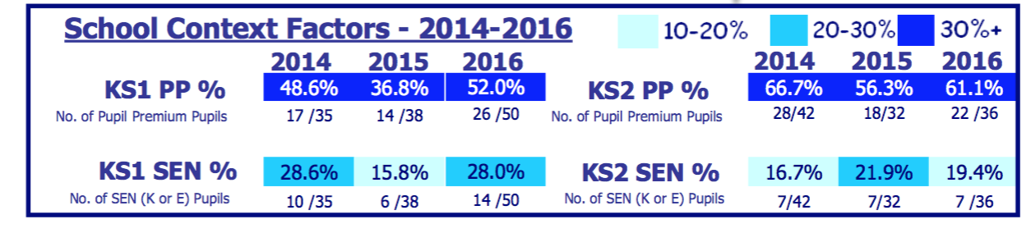
Support for Learning
Target | Cost | Pupil Premium |  | Summary |  | Outcome
High adult/ pupil ratio | 2 teachers M6 £84,00 | 52% = £43,680  Pupil Premium allocation  Plus an additional term £14,560  Total £58,240 |  | - Smaller teaching and pastoral groups |  | - Pupil premium pupils engage well with school.  - As a result, their attainment is at least at Age Related Expectations (ARE) and they make good progress.
Interventions across school | 10% of TA Salaries = £44486 | 53% pupils are PP = £17,000  Plus an additional term £5,666  Total £22,666 |  | - Improved attainment and / or progress of identified pupils  - Reading, writing and maths interventions led by teacher / teaching assistants.  - Reviewed half termly.  - Must Moves identified on planning |  | - Interventions across school  - As a result, their attainment is at least at Age Related Expectations (ARE) and they make good progress.
Y6 Interventions | 4 teachers  £30 per week X 26 weeks = £3,120 | 4 teachers  £30 per week X 26 weeks = £3,120  Plus an additional term £1,040  Total 4,160 |  | - One to one tuition and small groups beyond the school day led by 4 x teachers  - Identified Y6 pupils Sept 2016 to May 2017 |  | - Identified pupils reach year 6 expected standard  - Identified pupils make at least expected progress
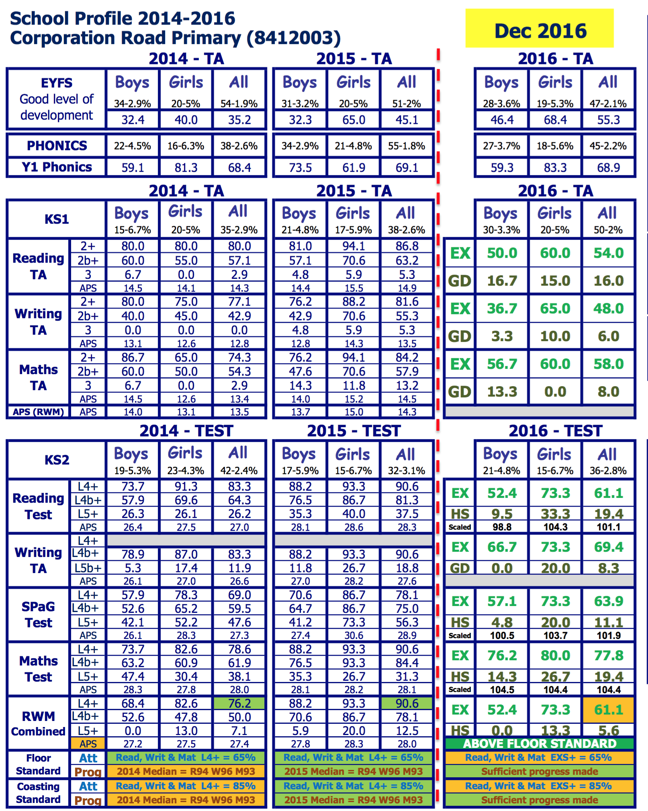

Outcomes 2015-2016
EYFS 2016 - Pupil Premium
38% of pupils are eligible for pupil premium - 18 pupils (10 boys and 8 girls).
56% of pupil premium pupils achieved the GLD compared to 55% of non pupil premium pupils. Therefore, there is an achievement gap of 0%. The National pupil premium gap is around 17% (PP 52% - NonPP 69%). The pupil premium gap is smaller than the National pupil premium gap

Year 1 Phonics 2016 - Pupil Premium
44% of pupils are eligible for pupil premium - 20 pupils (11 boys and 9 girls).
75% of pupil premium pupils achieved the GLD compared to 64% of non pupil premium pupils. Therefore, there is an achievement gap of 11%. The National pupil premium gap is around 14% (PP 66% - NonPP 80%). The pupil premium gap is smaller than the National pupil premium gap

Key Stage 1 Reading, Writing & Maths combined 2016 - Pupil Premium (expected standard)
52% of pupils are eligible for pupil premium - 26 pupils (14 boys and 12 girls).
31% of pupil premium pupils achieved the expected standard compared to 54% of non pupil premium pupils. Therefore, there is an achievement gap of 23%.

Key Stage 2 SAT Results - Reading, Writing and Maths combined 2016 - Pupil Premium (expected Standard)
61% of pupils were eligible for pupil premium - 22 pupils (14 boys and 8 girls).
64% of pupil premium pupils achieved the expected standard compared to 57% of non pupil premium pupils.

Speech and Language | £7,880  £200 per day x 39 weeks | Speech and language and PP 13/20= 65%  Plus an additional term £1,654  Total £9534 |  | - Individual support for children identified with speech and language. Individualised programmes |  | - Improved communication skills supporting children towards making better progress  - Improved attainment and / or progress of identified pupils. Children are integrated within school and self-esteem is improved.  - Parents more able to support their child’s language development skills
- May 2017
- 13/20 Pupil Premium children
- All children making progress in phonological awareness progress and some in speech sound progress
PCSO | £7,000 | 52% =  £3,640 |  | - Children attend school regularly and on time. Families supported with attendance issues and concerns |  | - Children access all areas of the curriculum and are better able to engage in their learning and show school readiness
- PCSO was terminated at Christmas 2016 and replaced with a rigorous system which has seen our attendance improve to 96.4% (May 2017)
- HLTA tasked with monitoring attendance and lates and following this up with parents and carers
- Half-termly 'Team around the school" meeting supports with any attendance issues
- Lates reduced from, 1470 in September 2014, to 433 in April 2017, a reduction of 1037
Educational Psychologist | £5,000 | 52% PP =  £2,500  Plus an additional term £833  Total £3,333 |  | - Additional EP support  - Identified pupils with SEN across the school Sept 2016 to July 2017 |  | - Improved strategies for teaching and learning which improve attainment and/or progress of identified pupils
- Professional CPD given to teachers to up skill staff and support children across school
- Thirteen identified children have an individual report, SEN profile, with suggested strategies and resources to support
- Parents have been supported at home with advice and guidance
- Input given for EHC and One Plans
Support for Social and Emotional Development
High adult/pupil ratio | 2 teachers M6 £84,00 |  | 52% = £43,680  Pupil Premium allocation  Plus an additional term  £14,560  Total £58,240 |  | - Smaller teaching and pastoral groups | - Pupil premium pupils engage well with school. As a result, their attainment is at least at Age Related Expectations (ARE) and they make good progress.
Marvellous Me | £1000 |  | 52% - £520  Plus an additional term £173  Total £693 |  | - Better engagement with pupils and parents across school | - Pupil Premium children and their parents engage well with school. As a result, their attainment is at least at Age Related Expectations (ARE) and they make good progress.
 | - Pupils with at least one parent engaged with Marvellous Me is 89%
School CAMHS worker | 1 day per week  £7,000 |  | Plus an additional term £1,166  Total £8,166  Pupil Premium 10/15 = 66%  £5389 |  | - Identified children receive bespoke intervention April 2016 to July 2017  - Reviewed half termly | - Pupils are more able to focus on learning and, as a result, attainment and / or progress improves.  - Improved behaviour around school / within lessons leading to improved attainment /progress of identified children.
- Mindfulness and pupil well-being training given to staff across school
- Children accessing direct support from Emotional wellbeing and mental health school team is 15 children 10 Pupil Premium
- All children making progress using measures employed to show progress in a range of factors
- Weekly parent group with SENCO and CAMHS worker replaced Home School Mentoring to improve parental engagement, improved relationships. Advice and support for individual pupils and families given
- Increased engagement by parents with parents more readily engaged and accepting of the support given
- Parent group increased in size from 1 to 10 (on average)
Nurture Group | 2 teachers 30 minutes a week for a term |  | £143.00 |  | - Small group of children access a nurturing groups to support with self-esteem and emotional well-being | - Children develop a positive mindset and develop resilience. As a result attainment and progress improves
Lunchtime Coaches | 2 coaches provide lunchtime sports activities and act as positive role models for small groups of children |  | 2 coaches x 1 hour - 4 times a week  £130 x 32  £4160,00 |  | - Coaches work with whole classes on lunchtime sports and activities  - Coaches support small groups of children in the dinner hall modelling high expectations and good manners | - Children are lesson ready after lunchtime  - Children show a positive attitude to learning  - Children have positive reinforcement of expectations of behaviour and attitude to learning
Breakfast Club | Catering supplies £3000  4 staff = £1,500 |  | 52% PP =  £2340  Plus an additional term £780  Total £3,120 |  | - Breakfast Club  - N to Y6  - Daily 8.00 am to 8.50 am | - Free breakfast will be provided for all children  - Attendance and punctuality improve for identified children. As a result attainment and or progress improve too.
- Numbers for Breakfast Club have increased from approximately 20 each day to around 68 every day
- Attendance has improved to 96.4% (May 2017) from 95.5 (September 2015)
- Lates reduced from, 1470 in September 2014, to 433 in April 2017, a reduction of 1037
EAL | Level 3 TA  £17,000 |  | 52% PP =  £8850  Plus an additional term £2,950  Total £11,800 |  | - Children with English as an additional language are given extra support to access the curriculum  - Parents who have English as an additional language are supported in school to improve outcomes for their children | - Pupil Premium with EAL are more able to focus on learning as a result their attainment is at lease at Age Related Expectations (ARE) and they make good progress  - Improved engagement with parents and families  - Pupils are more able to focus on learning and, as a result, attainment and / or progress improves.
- See progress above
- Level 3 TA delivering English classes supporting parents with the development of life skills to support their families with educational and health advice
Behaviour Support for 3 Level 3 Teaching Assistants afternoon sessions | £13,000  Plus an additional term £4,000 = £17,000 |  | 6/7 children Pupil Premium  85%  14,450 |  | - Focused behaviour support from 2 Level 3 teaching assistants in school for 'Learning Hub' | - Improved behaviour around school / within lessons leading to improved attainment /progress of identified children.  - Improved engagement with parents and families
- Progress for all groups and cohorts of children improving
- Low level behaviour improved within class
School Uniform | £1500  Plus an additional term £500  Total £2,000 |  |  |  | - Children and families are supported with Items of uniform where necessary | - All children feel a sense of belonging and no child is made to feel different. Resulting in higher self-esteem and more able to focus on their learning. As a result their attainment and or progress improves
School dinners | £1000  Plus an additional term £300  Total £1,300 |  |  |  | - Children and families are supported with providing their child(ren) with a school dinner when necessary | - Children are ready to learn. All children feel a sense of belonging and no child is made to feel different. Resulting in higher self-esteem and more able to focus on their learning. As a result their attainment and or progress improves
Improving the learning environment in the Early Years  £20,000 | £10,400  52% PP  (This is approximate as school are awaiting final quote) |  |  |  | - Children are able to access a learning environment conducive to their development of learning  - Children have access to an outdoor environment which supports and enhances their development and learning | - Children inspired by the curriculum and their learning is enhanced resulting in improved engagement in learning as well as improving attainment and/or progress  - Nursery and Reception children have access to separate environments to ensure all children in Early Years have access to high quality teaching and learning which specifically meet their needs and developmental milestones
 | - Projects to be completed in the Summer Term
Support for the Curriculum
Educational Visits Including year 6 residential | £7972 |  | 52% PP  £4,145 |  | - Costs of educational visits are subsidised. N to Y6 April 2016 to April 2016  - Cost of residential visit is subsidised. Y6 June 2016 | - Educational visits enhance the learning experiences resulting in improved engagement in learning, as well as improved attainment and /or progress.  - PP pupils are able to attend the residential visit.  - As a result relationships among children and staff are improved, resulting in improved attainment and/ or progress.
Improve the I.T. hardware across school | £125,866 |  | 52% PP  £65,450 |  | - Children have access to a secure server and I.T. systems that support safeguarding and improve learning | - Children inspired by the curriculum and their learning is enhanced resulting in improved engagement in learning as well as improving attainment and/or progress  - Children have access to a secure learning network which is clearly focused on e-safety and learning
High quality CPD to improve teaching and learning  Coaching training and purchase of assessment tracker and associated consultant training | £15,000  £12,960 |  | 52% PP  £7800  52%  £6,739 |  | - Wide range of CPD- external expertise, release for leading teachers to cascade training for staff.  - Support and Challenge Team and SLT to access CPD on coaching model to support all staff  - Children's progress is tracked regularly and accurately and staff are trained to monitor effectively | - Improvement in quality teaching – sharing good practise and ensuring staff are confident in delivery of high quality lessons to increase progress and attainment.  - Children's attainment and achievement is monitored effectively to ensure all children are making progress
High Quality Curriculum Resources to Inspire, motivate, challenge and engage | £6,000 |  | 52% PP  £3,120 |  | - Creative curriculum ‘Cornerstones’ bought into school to support learning and teaching across all age groups and all subject areas | - Children inspired by the curriculum and their learning is enhanced resulting in improved engagement in learning as well as improving attainment and/or progress
High quality texts purchased to inspire engage children to read and foster a 'love of reading' | £20,000 |  | 52% PP  £10,400 |  | - A wide range of 'real books' purchased with children playing an active part in their choice | - Children inspired to read with reading attainment and achievement increased
Children access a wide range of after school sports and extra-curricular activities | £350 per week x 20 weeks = £7,000 |  | 52% PP  £3640 |  | - Children are able to access a wide range of extra curricular activities | - Children are motivated to learn and are accessing a creative curriculum  - Children engaged in after school activates
Children have access to learning within an outdoor classroom | £6,000 |  | 52% PP  £3120 |  | - Children are able to access an environment which supports opportunities for mindfulness and exploration of the outdoors | - Children's well being and stimulated imagination supports and improves engagement in learning as well as improving attainment and/or progress
Music Support Service | £6000 |  | 53% PP  £3180 |  | - Access to high quality music support | - Children have experience and appreciation of music. Children have first hand experience of learning to play a musical instrument
Learning resources including the development of the library | £25,722 library |  | 53% PP  £13,375 |  | - Library developed and high quality texts identified to support learning and teaching  - High quality learning resources support children’s learning | - Children inspired by the curriculum and their learning is enhanced resulting in improved engagement in learning as well as improving attainment and/or progress  - The learning environment is conducive to inspiring and motivating the children to learn resulting in improved engagement in learning as well as improving attainment and/or progress
ICT learning resources | £17,303 |  | 52% PP  £9000 |  | - Additional resources / incentives to motivate pupils in IT, and those pupils below ARE.  - Computer system more able to support the needs of the school | - Children inspired by the curriculum and their learning is enhanced resulting in improved engagement in learning as well as improving attainment and/or progress
Support for the Family
Behaviour Support | £21,410 |  | 52% PP  = £11,300 |  | - Focused behaviour support within/ outside of the class R to Y6 | - Despite family crises children attend school regularly and on time, and continue to improve attainment and / or progress.  - Children and families are well supported in school.
- Two level 3 teaching assistants supported five children every afternoon within a Learning Hub in school.
- Sports coaches are allocated time every lunchtime to spend time with children within the Learning Hub.
- Lunchtime detentions are reducing as are internal and external exclusions
Total |  | £275,132

179,852

