Corporation Community Primary School
Pupil Premium Impact Report 2016/17 (September 2017 see below)
What is Pupil Premium Funding?
Pupil Premium Funding is allocated by the government to schools to support specific groups of children who are vulnerable to underachievement. Such pupils are identified as those entitled to free school meals (FSM), those looked after by the local authority and the children of armed service personnel.
The number of children identified as disadvantaged is way above the national average. 52% of pupils in the school fall under this classification compared to 18% nationally.

At Corporation Road Community Primary School we believe in supporting all children to do as well as they can, both socially and academically. In addition, we believe in supporting our families with issues that may impact on the children’s achievement and wellbeing.

Whilst we welcome Pupil Premium Funding we also recognise that prior to this specific funding we have always strived to support our children as best we can. Because of this, the ways in which we are using the funding are not necessarily new initiatives but rather a continuation of the good practice which was already in place.
We have identified five key areas on which we focus to improve outcomes for pupils eligible for pupil premium funding.
- Support for learning. To enable pupils to attain at least age related expectations and/ or make good progress in reading, writing and maths.
- Support for social development. To enable the child to be ready for learning by providing targeted support for behaviour, self-esteem and emotional well-being.
- Support for the curriculum. To ensure that pupils are able to access all aspects of the curriculum, including educational visits and residential trips, by providing financial support.
- Support for the family. To ensure that pupils are ready for learning by removing some of the barriers they experience through targeted work to improve attendance and punctuality, and through family support.
- Support for developing the environment across school to ensure children: have access to a library and books to promote a 'love of reading', are able to access an environment which inspires learning
- School became part of Lingfield Academy Trust in October 2016, as such this means that the school's budget now runs from September to September. In order to address this and update the school's Pupil Premium Report, a percentage of the budget has been added to this report to account for the number of Pupil Premium children on role from April 2017 - August 2017. This equates to an additional £72,000 added to the overall total.

Number of Pupils and pupil premium grant (PPG) received
Number on roll | 290 (excluding nursery)
Number of pupils eligible for PPG | 151
Percentage of pupils eligible for PPG | 52%
Amount of PPG per pupil | £180,840 plus an allocation of £72,000 to address the changes made to budget setting when joining Lingfield Academy Trust. Total £252,840
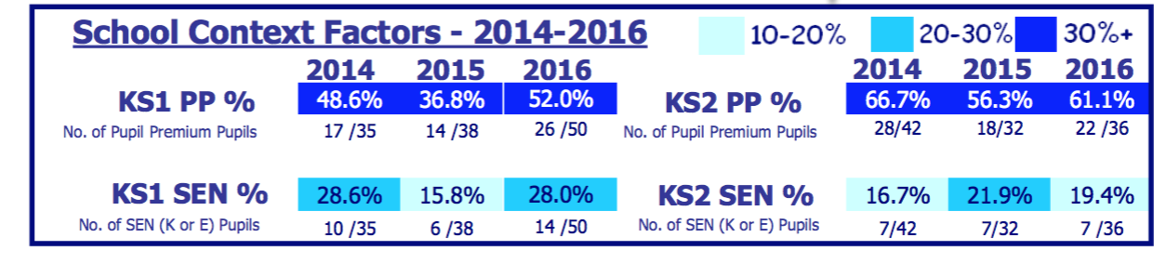

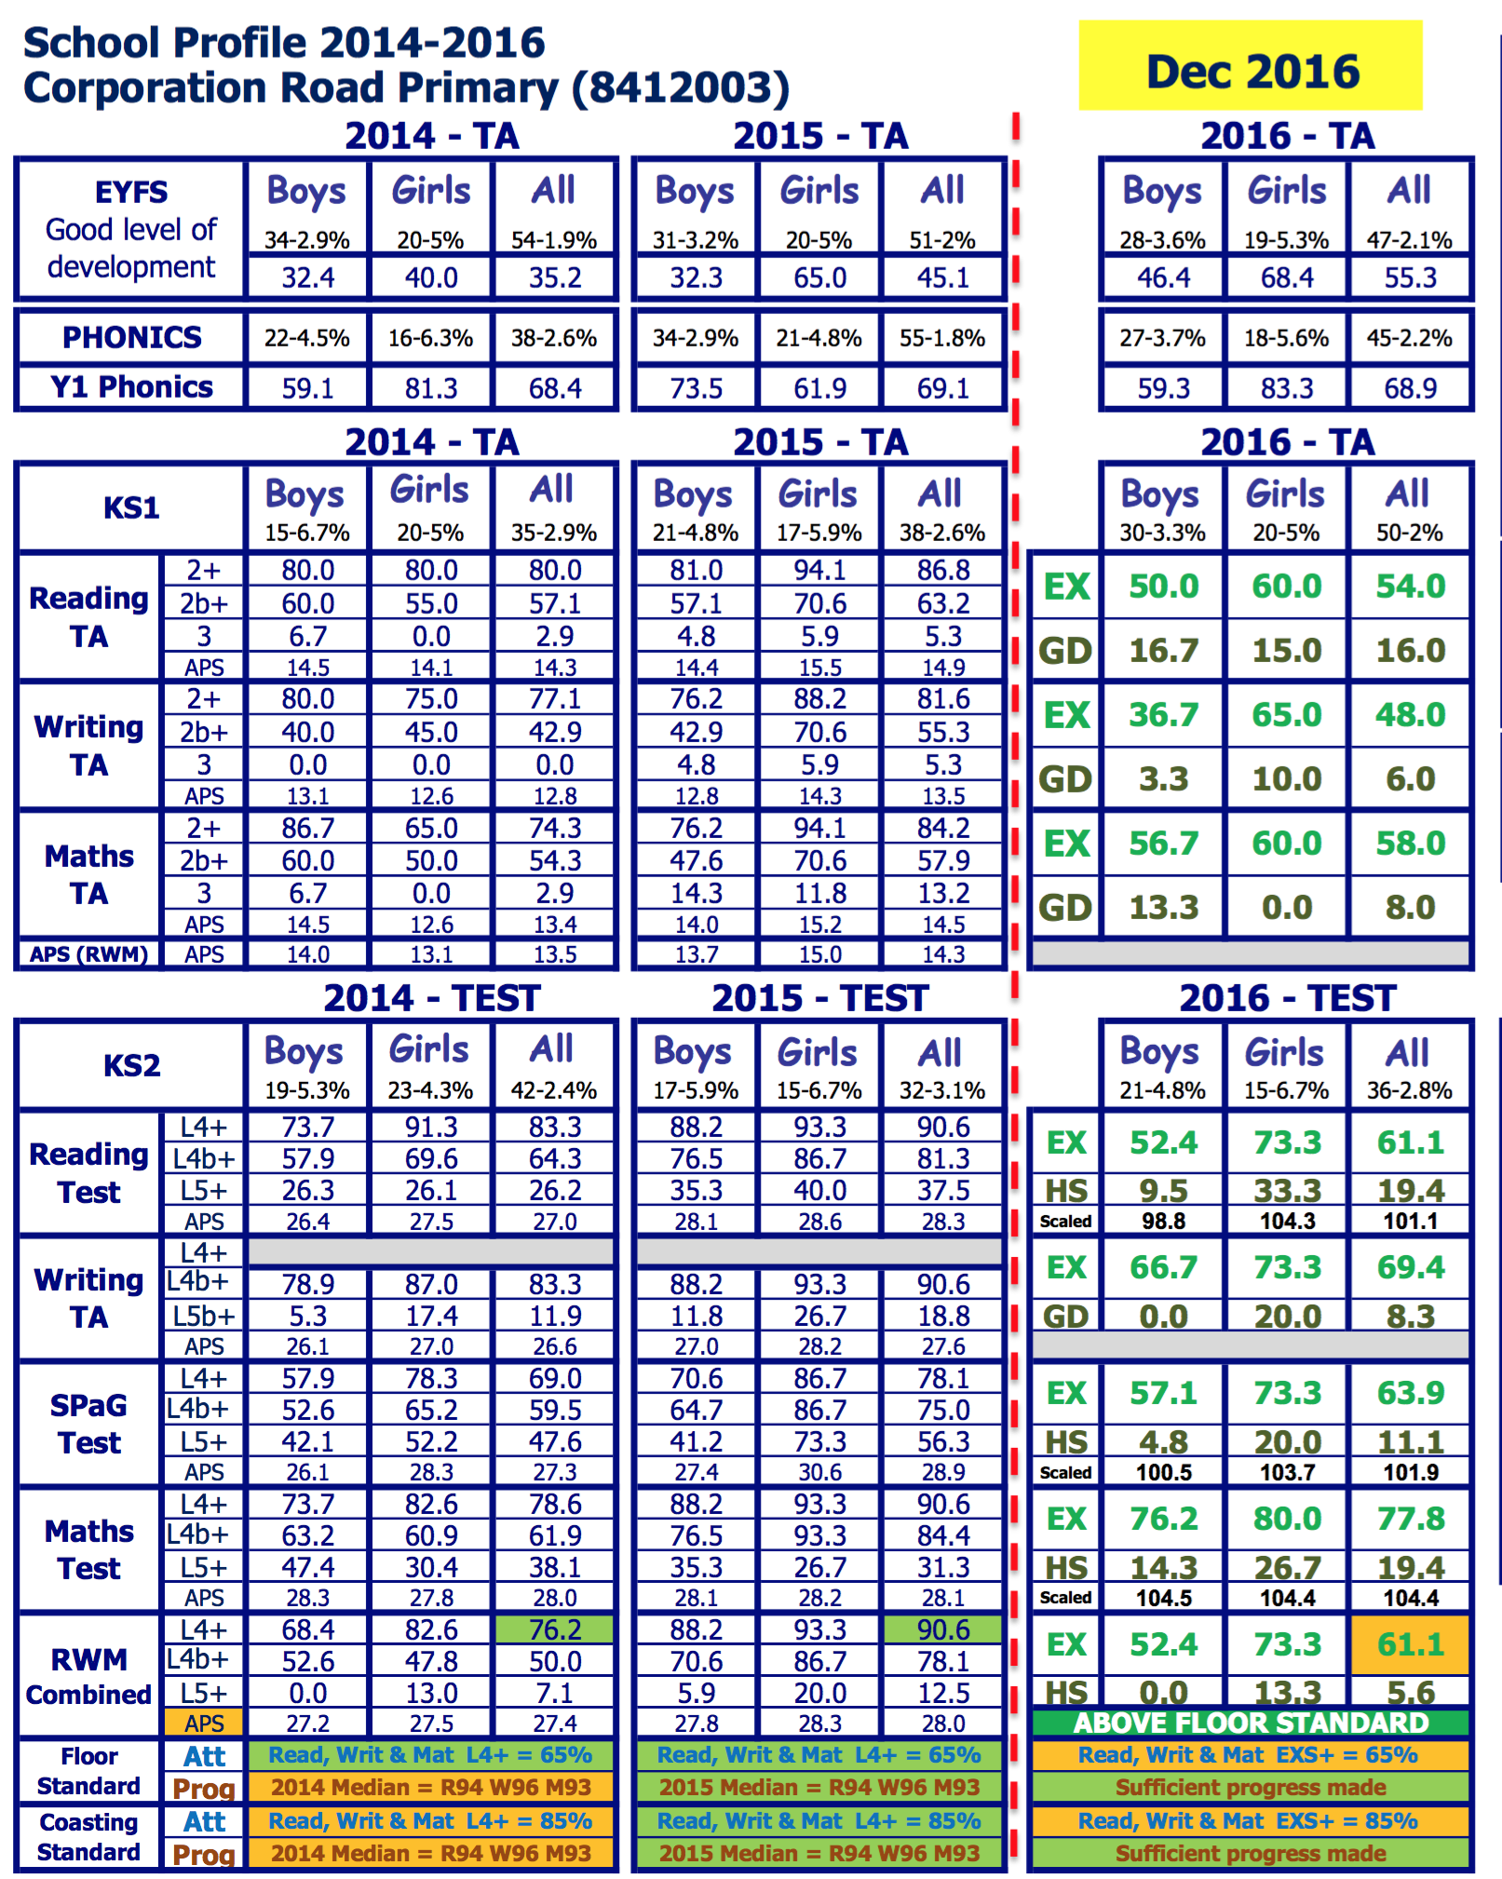

Outcomes 2015-2016
EYFS 2016 - Pupil Premium
38% of pupils are eligible for pupil premium - 18 pupils (10 boys and 8 girls).
56% of pupil premium pupils achieved the GLD compared to 55% of non pupil premium pupils. Therefore, there is an achievement gap of 0%. The National pupil premium gap is around 17% (PP 52% - NonPP 69%). The pupil premium gap is smaller than the National pupil premium gap

Year 1 Phonics 2016 - Pupil Premium
44% of pupils are eligible for pupil premium - 20 pupils (11 boys and 9 girls).
75% of pupil premium pupils achieved the GLD compared to 64% of non pupil premium pupils. Therefore, there is an achievement gap of 11%. The National pupil premium gap is around 14% (PP 66% - NonPP 80%). The pupil premium gap is smaller than the National pupil premium gap

Key Stage 1 Reading, Writing & Maths combined 2016 - Pupil Premium (expected standard)
52% of pupils are eligible for pupil premium - 26 pupils (14 boys and 12 girls).
31% of pupil premium pupils achieved the expected standard compared to 54% of non pupil premium pupils. Therefore, there is an achievement gap of 23%.

Key Stage 2 SAT Results - Reading, Writing and Maths combined 2016 - Pupil Premium (expected Standard)
61% of pupils were eligible for pupil premium - 22 pupils (14 boys and 8 girls).
64% of pupil premium pupils achieved the expected standard compared to 57% of non pupil premium pupils.

